
PATUAKHALI SCIENCE AND TECHNOLOGY UNIVERSITY
COURSE CODE CCE-211

SUBMITTED TO:

Prof. Dr. Md Samsuzzaman

Department of Computer and Communication Engineering
Faculty of Computer Science and Engineering

SUBMITTED BY:
Md. Sharafat Karim
ID: 2102024,
Registration No: 10151
Faculty of Computer Science and Engineering

Date of submission: 29 April, 2024
Assignment 02
Assignment title: Chapter 02

Q2-1. What is the first principle we discussed in this chapter for protocol layering that needs to be followed to make the communication bidirectional?
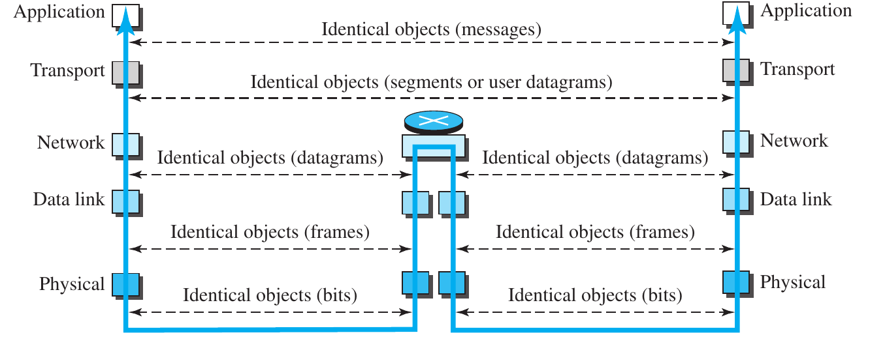
The first principle for making the communication bidirectional is to make sure, each layer needs to perform two opposite tasks.

Q2-2. Which layers of the TCP/IP protocol suite are involved in a link-layer switch?
In a link-layer switch Data link layer and Physical layer are involved.

Q2-3. A router connects three links (networks). How many of each of the following layers can the router be involved with?
a. physical layer
b. data-link layer
c. network layer
The router is involved with both three of them. One network layer, two physical layer and two data-link layer.

Q2-4. In the TCP/IP protocol suite, what are the identical objects at the sender and the receiver sites when we think about the logical connection at the application layer?
In the application layer, the identical object is message.

Q2-5. A host communicates with another host using the TCP/IP protocol suite. What is the unit of data sent or received at each of the following layers?
a. application layer
b. network layer
c. data-link layer
Layer name | Data unit
Application layer | Message
Network layer | Datagram
Data-link layer | Frame

Q2-6. Which of the following data units is encapsulated in a frame?
a. a user datagram
b. a datagram
c. a segment
In a frame, datagram is encapsulated.

Q2-7. Which of the following data units is decapsulated from a user datagram?
a. a datagram
b. a segment
c. a message
From a user datagram, a message is decapsulated.

Q2-8. Which of the following data units has an application-layer message plus the header from layer 4?
a. a frame
b. a user datagram
c. a bit
User datagram has an application-layer message and the header from layer 4.

Q2-9. List some application-layer protocols mentioned in this chapter.
Some application-layer protocols mentioned in this chapter are,
- HTTP (Hypertext Transfer Protocol)
- FTP (File Transfer Protocol)
- SNMP (The Simple Network Management Protocol)
- SSH (Secure Shell)
- TELNET (The Terminal Network)
- IGMP (The Internet Group Management Protocol)

Q2-10. If a port number is 16 bits (2 bytes), what is the minimum header size at the transport layer of the TCP/IP protocol suite?
The transport layer needs to add at least two port addresses. So at least 4 byte or 32 bits are required.

Q2-11. What are the types of addresses (identifiers) used in each of the following layers?
a. application layer
b. network layer
c. data-link layer
The type of addresses are,
Layer name | Type of addresses
Application layer | Names
Network layer | Logical addresses
Data-link layer | Link-layer addresses

Q2-12. Can you explain why we did not mention multiplexing/ demultiplexing services for the application layer?
The application layer is on the top and doesn’t provide services to any other layer. This is why multiplexing/ demultiplexing services for the application layer doesn’t exist.

Q2-13. Assume we want to connect two isolated hosts together to let each host communicate with the other. Do we need a link-layer switch between the two?
We don’t need link-layer in this case, because it is already one to one communication from a host to another.

Q2-14. Explain. If there is a single path between the source host and the destination host, do we need a router between the two hosts?
No, we don’t need router in this case because there is only one host.

P2-1. Answer the following questions about Figure 2.2 when the communication is from Maria to Ann:
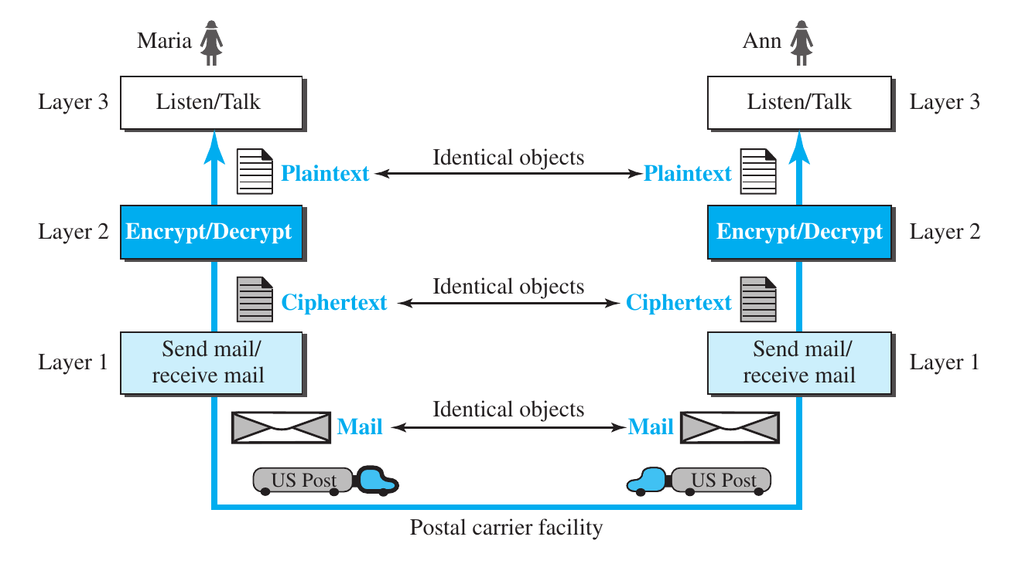
a. What is the service provided by layer 1 to layer 2 at Maria’s site?
Layer 1 at Maria’s side, takes the encrypted message, puts it in an envelope and sends it.
b. What is the service provided by layer 1 to layer 2 at Ann’s site?
Layer 1 at Ann’s side, receives the message, removes the envelope and forwards it to the Layer 2 for decryption.

P2-2. Answer the following questions about Figure 2.2 when the communication is from Maria to Ann:
(same figure as P2-1)
a. What is the service provided by layer 2 to layer 3 at Maria’s site?
Layer 2 at Maria’s side, takes the message as plain text, encrypts it and forward to the Layer 1.
b. What is the service provided by layer 2 to layer 3 at Ann’s site?
Layer 2 at Ann’s side, takes the encrypted text from Layer 1, decrypts it and forwards it to the Layer 3.

P2-3. Assume that the number of hosts connected to the Internet at year 2010 is five hundred million. If the number of hosts increases only 20 percent per year, what is the number of hosts in year 2020?
In 2010, the number of hosts connected to the internet is 500,000,000. So if the increase percentage is 20% or, 0.2, in 2020 the number will be around (1.20¹⁰ or 6.2) 6 times as of 2010. So the number will be more than 3,100,000,000.

P2-4. Assume a system uses five protocol layers. If the application program creates a message of 100 bytes and each layer (including the fifth and the first) adds a header of 10 bytes to the data unit, what is the efficiency (the ratio of application-layer bytes to the number of bytes transmitted) of the system?
Total number of byte = five layer + header = 100 + ( 10 x 5 ) = 150 byte
So, the efficiency =
=
= 66.66%

P2-5. Assume we have created a packet-switched internet. Using the TCP/IP protocol suite, we need to transfer a huge file. What are the advantage and disadvantage of sending large packets?
While sending large packets, TCP/IP protocol splits the packages into smaller sub-packages which makes the communication easier. On the other hand, corrupted sub-packages can break the large package while combining all pieces together.

P2-6. Match the following to one or more layers of the TCP/IP protocol suite:
a. route determination
b. connection to transmission media
c. providing services for the end user
Purpose | Corresponding layer name
Route determination | Network layer
Connection to transmission media | Physical layer
Providing services for the end user | Application layer

P2-7. Match the following to one or more layers of the TCP/IP protocol suite:
a. creating user datagrams
b. responsibility for handling frames between adjacent nodes
c. transforming bits to electromagnetic signals
Purpose | Corresponding layer name
Creating user datagrams | Transport layer
Responsibility for handling frames between adjacent nodes | Data-link layer
Transforming bits to electromagnetic signals | Physical layer

P2-8. In Figure 2.10, when the IP protocol decapsulates the transport-layer packet, how does it know to which upper-layer protocol (UDP or TCP) the packet should be delivered?
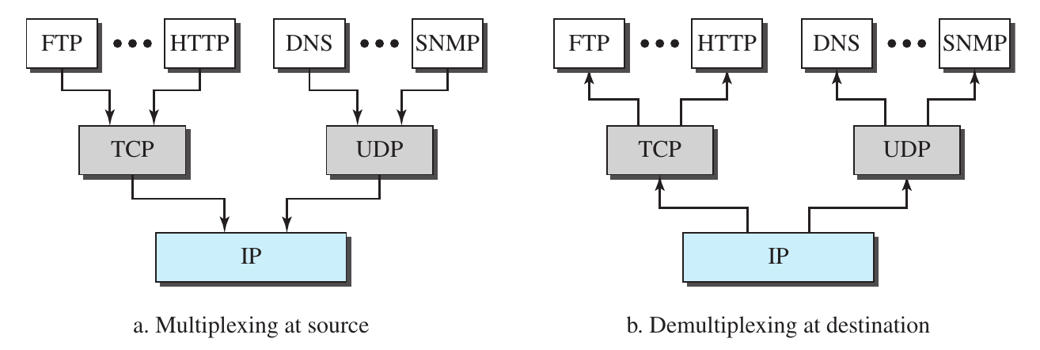
In a transport-layer packet, in the header file of the packet, there’s an identifier to figure out, which upper-layer protocol the packet should be delivered.

P2-9. Assume a private internet uses three different protocols at the data-link layer (L1, L2, and L3). Redraw Figure 2.10 with this assumption. Can we say that, in the data-link layer, we have demultiplexing at the source node and multiplexing at the destination node?
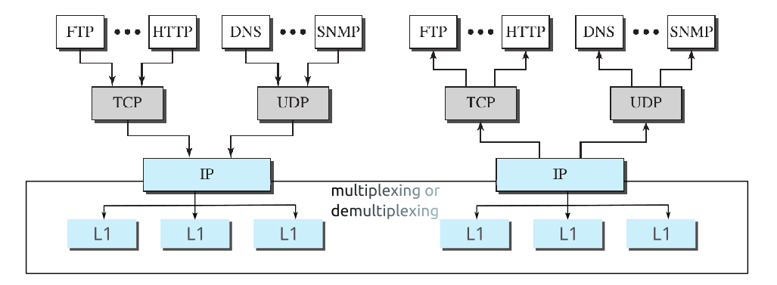
Yes, we can say that we can have demultiplexing at the source node and multiplexing at the destination if the receiver transmits or, return a data or signal.

P2-10. Assume that a private internet requires that the messages at the application layer be encrypted and decrypted for security purposes. If we need to add some information about the encryption/decryption process (such as the algorithms used in the process), does it mean that we are adding one layer to the TCP/IP protocol suite? Redraw the TCP/IP layers (Figure 2.4 part b) if you think so.
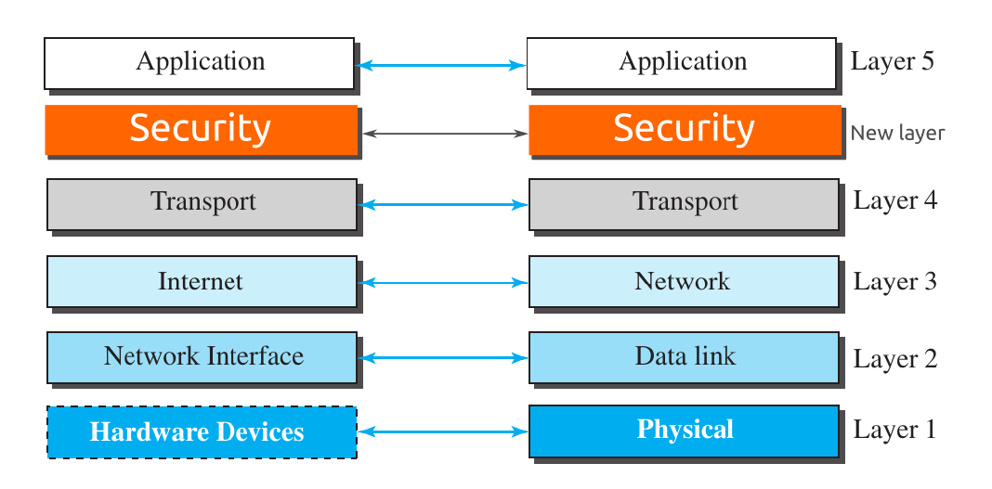
Yes, in this case we can think it as a new layer where, information is encrypted or decrypted. And we can use it’s header file for storing the algorithms in which information is being encrypted. A Similar figure with a new layer is shown above.

P2-11. Protocol layering can be found in many aspects of our lives such as air travelling. Imagine you make a round-trip to spend some time on vacation at a resort. You need to go through some processes at your city airport before flying. You also need to go through some processes when you arrive at the resort airport. Show the protocol layering for the round trip using some layers such as baggage checking/claiming, boarding/unboarding, takeoff/landing.
We can think it as the same way as network protocols. At each side we will have two opposite tasks with identical mechanism.
- Both at the source and the destination, we will check baggage.
- Then at the same time in the source we will have to board and at the destination we have to be un-board.
- Again at the source destination we have to take off and at the destination we have to land.
And the vice versa will occur when we will again return to source from destination.

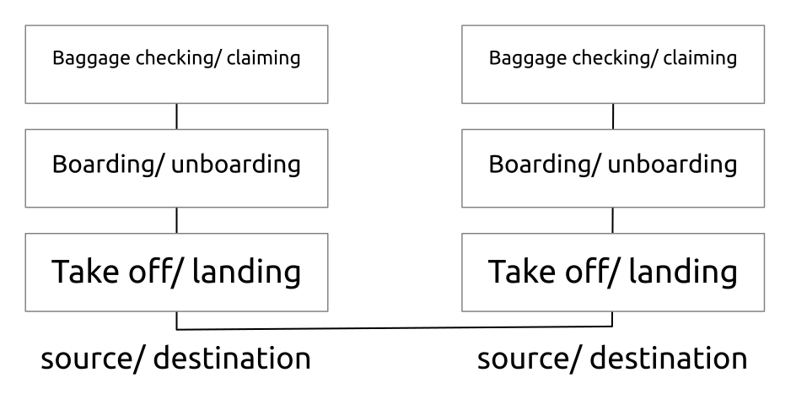
P2-12. The presentation of data is becoming more and more important in today’s Internet. Some people argue that the TCP/IP protocol suite needs to add a new layer to take care of the presentation of data. If this new layer is added in the future, where should its position be in the suite? Redraw Figure 2.4 to include this layer.
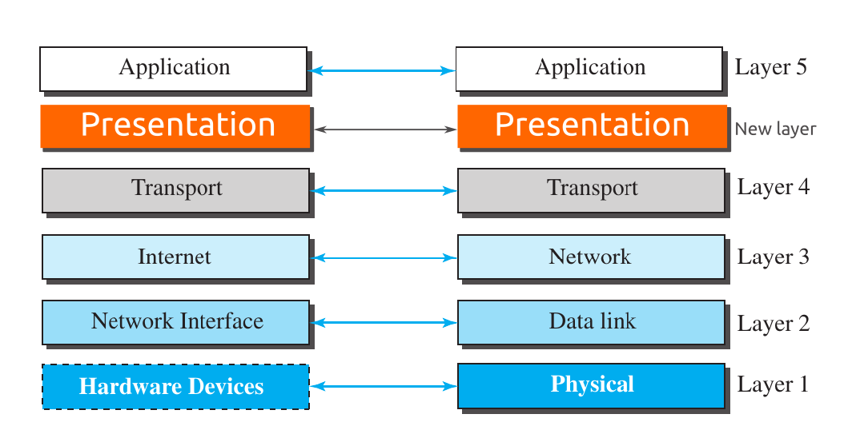
Yes, adding a new layer is possible. We can add this new layer after Application layer. In this way, Presentation layer will take the message from application to represent data such as encryption algorithms. And presentation layer will again pass data to the transport layer.

P2-13. In an internet, we change the LAN technology to a new one. Which layers in the TCP/IP protocol suite need to be changed?
For changing LAN technology to an new one, we may need to replace two layers, data-link layer and physical layer. Data link layer binds the link layer address and physical layer actually transmits the data. So instead of replacing the whole model, we can just change these two layer.

P2-14. Assume that an application-layer protocol is written to use the services of UDP. Can the application-layer protocol uses the services of TCP without change?
We can’t access TCP without change. As UDP and TCP works in two different way we need to change the application layer a bit. But we don’t need to replace the entire model.

P2-15. Using the internet in Figure 1.11 (Chapter 1) in the text, show the layers of the TCP/IP protocol suite and the flow of data when two hosts, one on the west coast and the other on the east coast, exchange messages.
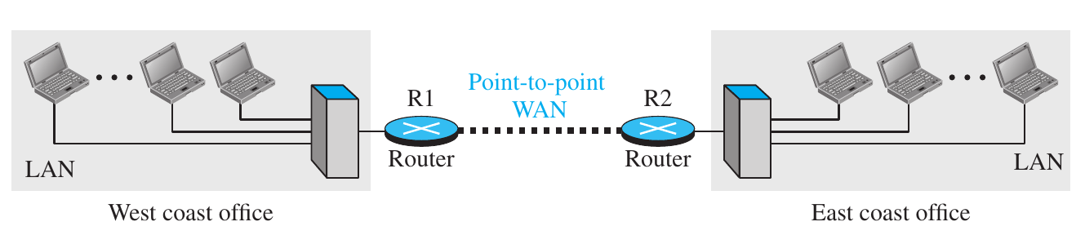
Here for the west coast office and east coast office to be connected, we need to add these two WAN through router. We can use 5 TCP/ IP layers to achieve this. The following image shows the layers of TCP/IP protocol suite to achieve this communication.
